According to Intelli, the Poland orthopedic devices market was valued at USD 420.0 million in 2024 and is projected to reach USD 681.07 million by 2032, growing at a CAGR of 7.13% during the forecast period.

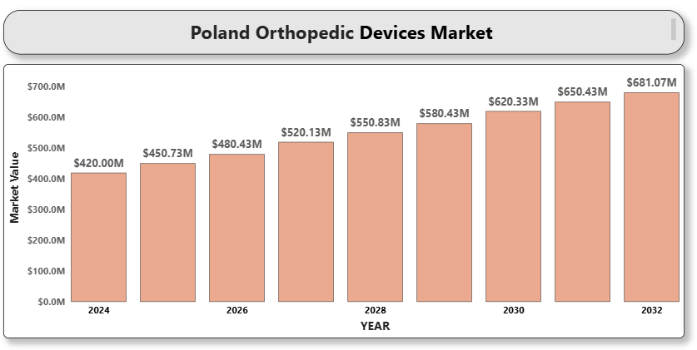

This growth is attributed to rising demand for joint replacements, improvements in hospital infrastructure, and increasing investments in advanced orthopedic technologies across both public and private sectors. In particular, the aging populations in Poland and rising cases of orthopedic disorders such as osteoarthritis and spinal deformities have spurred demand for surgical solutions. Additionally, government-led healthcare reform and strategic collaborations between local healthcare providers and multinational companies are accelerating the adoption of innovative orthopedic treatments.

**Poland Orthopedic Devices Market Definition**

Orthopedic devices are medical tools used to prevent or correct disorders in bones, joints, ligaments, tendons, and muscles. These include implants, joint reconstruction products, spinal devices, trauma fixation equipment, and arthroscopic tools. They are designed to restore mobility, relieve pain, and enhance patients' quality of life, particularly in individuals suffering from injuries, degenerative conditions, or congenital deformities. These devices play a crucial role in orthopedic surgeries, sports medicine, and post-trauma rehabilitation, supporting improved clinical outcomes and faster recovery. Their development is continually influenced by material science innovations and evolving surgical techniques.

**Poland Orthopedic Devices Market Overview**

The orthopedic devices market in Poland is driven by a growing elderly population, rising prevalence of osteoporosis and arthritis, and improvements in healthcare access and infrastructure. Increasing awareness about early diagnosis and orthopedic surgeries, coupled with favorable government policies and EU health funding, have supported market expansion. Adoption of advanced technologies such as 3D-printed implants, navigation systems, and robot-assisted surgeries is further boosting market growth. Public health insurance and reimbursement systems also support broader access to orthopedic procedures, while private healthcare providers are expanding their orthopedic offerings. Additionally, medical tourism is gaining traction, with Poland becoming a preferred destination for affordable and high-quality orthopedic care, drawing patients from neighboring countries due to shorter waiting times and specialized treatments.

**Poland Orthopedic Devices Market Segmentation Analysis Market Segmentation by Product** **Type:**

* Joint Reconstruction
  + Hip Replacement
  + Knee Replacement
  + Shoulder Replacement
* Spinal Devices
  + Fusion Devices
  + Non-fusion Devices
* Trauma Fixation Devices
  + Plates and Screws
  + Pins and Wires
* Arthroscopy Devices
* Orthobiologics
* Others

**Market Segmentation by End User:**

* Hospitals
* Orthopedic Clinics
* Ambulatory Surgical Centers
* Rehabilitation Centers

Hospitals are the largest end-user segment due to better surgical facilities and qualified professionals. Ambulatory surgical centers are gaining traction due to cost-efficiency and quicker recovery time.

**Market Segmentation by Region:**

* Central Poland
* Southern Poland
* Northern Poland
* Eastern Poland

Southern and Central Poland dominate the market due to higher healthcare infrastructure and larger patient populations. Northern and Eastern Poland show growth potential with increasing orthopedic care investments.

Key Players Key players in the Poland orthopedic devices market include Zimmer Biomet Holdings Inc., Stryker Corporation, Johnson & Johnson (DePuy Synthes), Smith & Nephew plc, Medtronic plc, B. Braun Melsungen AG, NuVasive Inc., Globus Medical Inc., and Arthrex Inc.

**Key Developments**

* In Nov 2024, Zimmer Biomet received CE certification for its Persona OsseoTi Keel Tibia, an advanced knee implant that enhances osseointegration.
* In February 2024, Stryker launched the Mako Total Hip 4.0 robotic-arm-assisted surgery system in Poland to improve surgical accuracy.
* In January 2024, Smith & Nephew expanded its orthopedic training center in Warsaw to support skills development in advanced joint replacement techniques.

**Market Attractiveness**

Poland presents a favorable orthopedic devices market with increasing surgical procedures, demand for quality implants, and supportive insurance schemes. Advancements in materials and digital surgery technologies further enhance opportunities.

**Porter's Five Forces**

* Threat of New Entrants: Moderate. Strong brand presence and regulatory requirements limit easy entry.
* A close-up of hands holding a tablet and a pen

  Description automatically generatedBargaining Power of Suppliers: Moderate. Dependence on specialized raw materials and component suppliers.
* Bargaining Power of Buyers: High. Price-sensitive hospitals and tender-based procurement put pressure on manufacturers.
* Threat of Substitutes: Low. Limited substitutes exist for surgical orthopedic treatments.
* Industry Rivalry: High. Competitive environment with frequent innovation and pricing competition.

**TABLE OF CONTENTS**

1. **INTRODUCTION OF POLAND ORTHOPEDIC DEVICES MARKET**

1.1 Overview of the Market

1.2 Scope of Report

1.3 Assumptions

1. **EXECUTIVE SUMMARY**
2. **RESEARCH METHODOLOGY**

3.1 Data Mining

3.2 Validation

3.3 Primary Interviews

3.4 List of Data Sources

1. **POLAND ORTHOPEDIC DEVICES MARKET OUTLOOK**

4.1 Overview

4.2 Market Dynamics

4.2.1 Drivers

4.2.2 Restraints

4.2.3 Opportunities

4.2.4 Trends

4.3 Porter’s Five Force Model

4.4 Value Chain Analysis

1. **POLAND ORTHOPEDIC DEVICES MARKET, BY PRODUCT TYPE**

5.1 Joint Reconstruction

5.2 Spinal Devices

5.3 Trauma Fixation Devices

5.4 Arthroscopy Devices

5.5 Orthobiologics

5.6 Others

1. **POLAND ORTHOPEDIC DEVICES MARKET, BY END USER**

6.1 Hospitals

6.2 Orthopedic Clinics

6.3 Ambulatory Surgical Centers

6.4 Rehabilitation Centers

1. **POLAND ORTHOPEDIC DEVICES MARKET, BY REGION**

7.1 Central Poland

7.2 Southern Poland

7.3 Northern Poland

7.4 Eastern Poland

1. **POLAND ORTHOPEDIC DEVICES MARKET COMPETITIVE LANDSCAPE**

8.1 Overview

8.2 Company Market Ranking

8.3 Key Development Strategies

1. **COMPANY PROFILES**

**9.1 Zimmer Biomet Holdings Inc.**

9.1.1 Overview

9.1.2 Financial Performance

9.1.3 Product Outlook

9.1.4 Key Developments

**9.2 Stryker Corporation**

9.2.1 Overview

9.2.2 Financial Performance

9.2.3 Product Outlook

9.2.4 Key Developments

**9.3 Johnson & Johnson (DePuy Synthes)**

9.3.1 Overview 9.3.2 Financial Performance

9.3.3 Product Outlook

9.3.4 Key Developments

**9.4 Smith & Nephew plc**

9.4.1 Overview

9.4.2 Financial Performance

9.4.3 Product Outlook

9.4.4 Key Developments

**9.5 Medtronic plc**

9.5.1 Overview

9.5.2 Financial Performance

9.5.3 Product Outlook

\9.5.4 Key Developments

**9.6 B. Braun Melsungen AG**

9.6.1 Overview

9.6.2 Financial Performance

9.6.3 Product Outlook

9.6.4 Key Developments

**9.7 NuVasive Inc.**

9.7.1 Overview

9.7.2 Financial Performance

9.7.3 Product Outlook

9.7.4 Key Developments

**9.8 Globus Medical Inc.**

9.8.1 Overview

9.8.2 Financial Performance

9.8.3 Product Outlook

9.8.4 Key Developments

**9.9 Arthrex Inc.**

9.9.1 Overview

9.9.2 Financial Performance

9.9.3 Product Outlook

9.9.4 Key Developments

1. **KEY DEVELOPMENTS**

10.1 Product Launches/Developments

10.2 Mergers and Acquisitions

10.3 Business Expansions

10.4 Partnerships and Collaborations

1. **APPENDIX**

11.1 Related Research